SWEN-383

Diet Manager

Bruno Maleš
Đorđe Vulević
Toni Vlašić

Version 2.0

INTRODUCTION

For our final project we created Diet Manager java application. It is a application that users can use to control intake of calories, planning meals etc.
These are functionalities of our application:
1. You can add food to the database.

2. You can create recepies from food that you have in database.

3. You can see data from database at any time.

4. You can add recipes to the database

5. You can log food that you ate in a specific day.

6. You can check what you ate at which day.

7. You can check how many calories you ate and how many you burned.

Patterns that we used are MVC, Observer, Decorator and Factory. Every pattern will be explained in details in presentation.

UML DIAGRAM
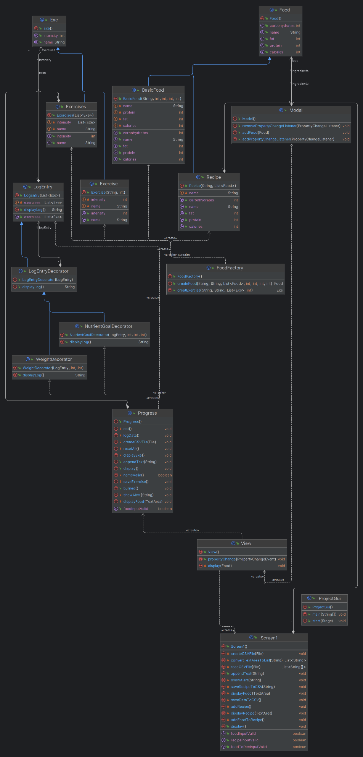

SEQUENCE DIAGRAM

SEQUENCE DIAGRAM

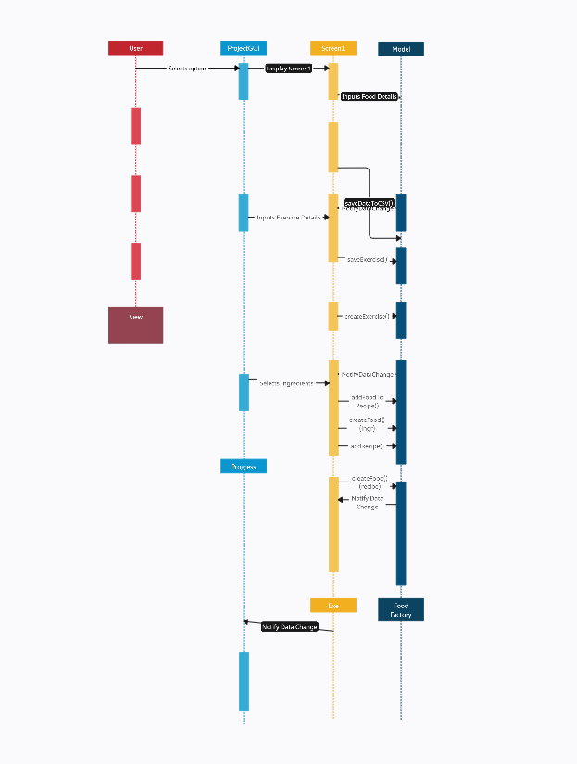

DESIGN

DESIGN

